LAB REPORT 2

Pertemuan 1. Motor DC – Driver Motor

Nama : Faiqoh Rohadatul Aisy

NIM : 20/462080/PA/20052

Tanggal : 6 September 2021

Asisten : Rizki Fajar Kurniawan

1. **Transistor dan Motor DC**

|  |  |  |  |
| --- | --- | --- | --- |
| No | Tegangan (V) | Arus (A) | Arah |
| 1. | 11,8 | 0,11 | CW |
| 2. | 11,7 | 0,21 | CW |
| 3. | 11,6 | 0,30 | CW |
| 4. | 11,5 | 0,38 | CCW |
| 5. | 11,4 | 0,47 | CCW |
| 6. | 11,3 | 0,56 | CCW |
| 7. | 11,1 | 0,66 | CW |
| 8. | 11,1 | 0,74 | CW |
| 9. | 11,0 | 0,82 | CW |
| 10. | 10,9 | 0,90 | Not rotate |

Grafik Tegangan (V) vs Arus (A)

Skematik

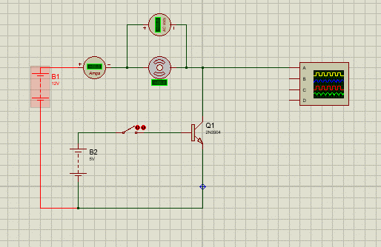

Bentuk sinyal saat motor dinyalakan

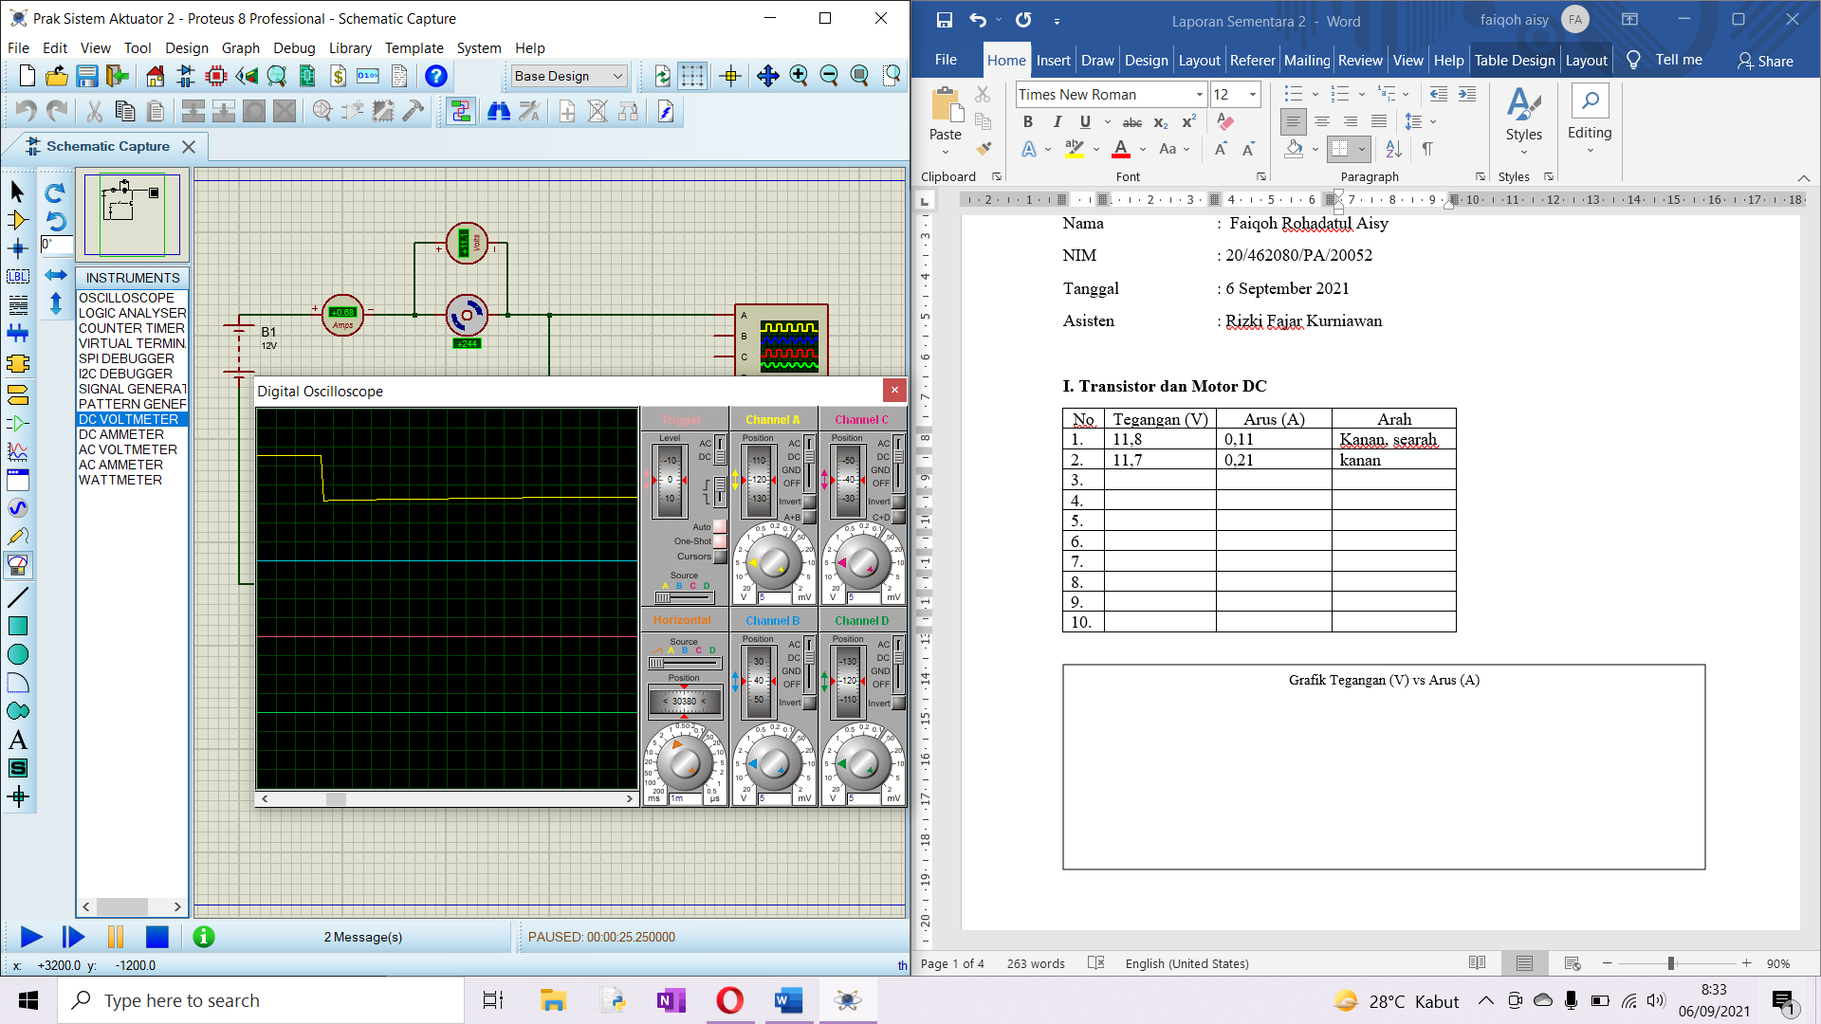

1. **Arah Gerak Motor**

| No | L0 | L1 | Arah |
| --- | --- | --- | --- |
| 1. | 0 | 0 | Not rotating |
| 2. | 0 | 1 | CW |
| 3. | 1 | 0 | CCW |
| 4. | 1 | 1 | Not rotation |

|  |  |  |  |
| --- | --- | --- | --- |
| No | Tegangan (V) | Arus (A) | Arah |
| 1. | -1,78 | -0,07 | CW |
| 2. | -1,23 | -0,05 | CW |
| 3. | -9,01 | -0,38 | CW |
| 4. | -8,46 | -0,35 | CW |
| 5. | -0,80 | -0,03 | CW |
| 6. | -1,35 | -0.05 | CW |
| 7. | -7,68 | -0,32 | CW |
| 8. | -7,12 | -0,30 | CW |
| 9. | -5,78 | -0,24 | CW |
| 10. | -6,33 | -0,26 | CW |

Skematik

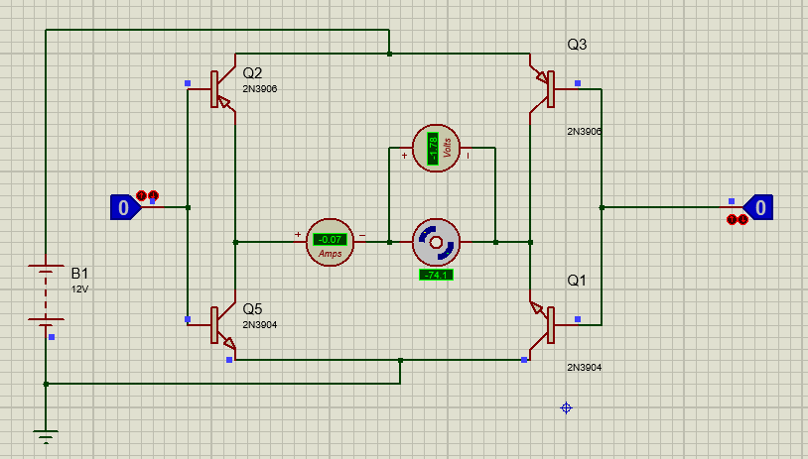

1. **Merangkai IC Driver Motor**

| No | E1 | I1 | I2 | O1 | O2 | Arah |
| --- | --- | --- | --- | --- | --- | --- |
| 1. | 0 | 0 | 0 | 0 | 0 | Not Rotation |
| 2. | 0 | 0 | 1 | 0 | 0 | Not Rotation |
| 3. | 0 | 1 | 0 | 0 | 0 | Not Rotation |
| 4. | 0 | 1 | 1 | 0 | 0 | Not Rotation |
| 5. | 1 | 0 | 0 | 0 | 0 | Not Rotation |
| 6. | 1 | 0 | 1 | 0 | 1 | CCW |
| 7. | 1 | 1 | 0 | 1 | 0 | CW |
| 8. | 1 | 1 | 1 | 1 | 1 | Not Rotation |

|  |  |  |  |
| --- | --- | --- | --- |
| No | Tegangan (V) | Arus (A) | Arah |
| 1. | 5 | 0.19 | CW |
| 2. | 6 | 0.23 | CW |
| 3. | 7 | 0.27 | CW |
| 4. | 8 | 0.31 | CW |
| 5. | 9 | 0.34 | CW |
| 6. | 10 | 0.38 | CW |
| 7. | 11 | 0.42 | CW |
| 8. | 12 | 0.46 | CW |
| 9. | 13 | 0.50 | CW |
| 10. | 14 | 0.54 | CW |

Bentuk Sinyal saat Motor dinyalakan

Bentuk sinyal sat diberi hambatan

1. **Tugas**

| No | E1 | I1 | I2 | O1 | O2 | Arah |
| --- | --- | --- | --- | --- | --- | --- |
| 1. | 0 | 0 | 0 |  |  |  |
| 2. | 0 | 0 | 1 |  |  |  |
| 3. | 0 | 1 | 0 |  |  |  |
| 4. | 0 | 1 | 1 |  |  |  |
| 5. | 1 | 0 | 0 |  |  |  |
| 6. | 1 | 0 | 1 |  |  |  |
| 7. | 1 | 1 | 0 |  |  |  |
| 8. | 1 | 1 | 1 |  |  |  |

1. **Pertanyaan**
2. Apa bedanya menggunakan transistor dan tanpa transistor?
3. Bagaimana cara kerja H Bridge mengatur arah gerak motor?
4. Bagaimana bentuk sinyal tegangan motor saat terhubung ke driver
5. Apa itu enable? Kenapa diperlukan?
6. Apa pengaruh penggunaan 1 motor dan 2 motor pada driver l293D?